Assessment of Student’s Competence 2022–

Name of the teacher student

Name of the guiding teacher

The teaching practice place
At the end of the training period, the guiding teacher assesses the student's competence using this form. The teacher signs the evaluation form, gives it to the student and also sends it to the tutor of the School of Professional Teacher Education by e-mail.

The assessment will focus on the competence goals 19-23 mentioned below. The assessment criteria on pages 2-3 may be used selectively.

Competence goals | Assessment of the guiding teacher
19. You plan a learning module in your own substance field.

20. You will execute a learning module in your own substance field according to the implementation plan prepared by you.

21. You evaluate and provide feedback on learning, competence and professional growth.

22. You act responsibly and professionally in your teaching and tutoring.
23. You develop your own work as a teacher and tutor.
Here the student adds any other competence goals in which the student wants to demonstrate their competence in during the teaching practice.

Other feed-back of the guiding teacher

Signature, date and email

Oulu University of Applied Sciences
Competence goals and assessment criteria
Teaching Practise, 12 cr
Competence goals | Assessment criteria
19. You plan a learning module in your own substance field. | Familiarization with the teaching practice institution  a) You know the professional field, tasks and student body of a higher education teacher.  b) You know who takes care of the well-being of students (e.g. co-teacher, special needs teacher, curator, pastor, guidance counsellor, psychologist, or nurse).  c) You know the learning and digital environments of the practise institution and also their specific features and consider the opportunities they offer in your implementation plan.  d) You know how to implement the competence-based approach in your learning module.  Implementation plan  e) You will create an implementation plan for your teaching, observing the qualification requirements/curriculum and the documents and principles that guide the planning of teaching, guidance and assessment.  f) You will include in your implementation plan a description of the content of the learning module, a description of the learning process and learning methods, and an assessment plan.  g) In your implementation plan, you take into account the initial level of students' competence and other possible factors that affect teaching, guidance, learning and assessment (such as special support needs, multiculturalism)  h) You include in your implementation plan a safety survey that takes into account the physical, mental and social safety of the students and the institution-specific safety instructions and documents related to the teacher's work.  i) You plan the teaching unit in cooperation with other parties involved in the implementation.  You justify your pedagogical solutions.
20. You will execute a learning module in your own substance field according to the implementation plan prepared by you. | Documentation, Curriculum  a) You teach and guide in a genuine educational context according to the qualification requirements / curriculum of your own substance field.  b) Your teaching will be guided by the implementation plan you have developed, and which you will evaluate and adjust as necessary.  c) You familiarize students with the professional competence requirements of the learning module for which you are responsible  d) You discuss the subjects of assessment, assessment criteria and methods with students  Interaction  e) You work in a student-centered way to interact with students and other actors to promote learning.  f) In all encounters, you will work reciprocally and to promote co-operation.  g) You work to promote accessibility in all encounters.  Teaching methods  h) You guide professional learning and the acquisition of skills, and you teach using a variety of teaching and guidance methods.  i) You guide the learning process and teach by applying current learning theories and pedagogical models.  Digitalisation  j) You use modern digital environments or tools in the context in which you teach, guide and assess.  Comprehensive guidance and special pedagogy (in line with the contents of the competence badges)  k) You guide students in accordance with the principles and practices of educational guidance.  l) You support students' personal and professional development.  m) You consider students' strengths and special support needs in your teaching and guidance.  n) You ensure the pedagogical accessibility of your teaching and guidance environment.  o) You use appropriate and pedagogically achievable teaching and guidance methods and materials.  Internationality and multiculturalism  p) You are able to create prerequisites for good learning for a multicultural study group in the context in which you teach and guide.  Research and working life cooperation  q) You integrate your own working life knowledge and, when possible, the networks of your field into your teaching.  You justify your pedagogical solutions.
21. You evaluate and provide feedback on learning, competence and professional growth. | a) You take into account the regulations, guidelines and practices pertaining to assessment.  b) You assess students' learning and competence in authentic teaching and guiding situations.  c) You take the student's individuality into account in the assessment and feedback.  You justify your pedagogical solutions.
22. You act responsibly and professionally in your teaching and tutoring. | Legislation  a) You comply with current higher education laws, regulations and guidelines.  Safety  b) You introduce students to work safety.  c) You follow the regulations, instructions and practices that ensure the physical, mental and social safety of the student and act in accordance with the safety survey you have created.  Ecosocial culture and sustainable development  d) You adhere to the principles of ecosocial culture and sustainable development.  e) You make the chosen principles visible to your students as appropriate.  Values and ethical principles  f) You take into account the values of higher education and the ethical principles of a teacher in your own substance field.  g) You take into account human rights, and equal treatment.  h) You work with diversity in mind while promoting inclusion.  You justify your actions.
23. You develop your own work as a teacher and tutor. | a) You get feedback on your own teaching, tutoring and interaction skills.  b) You reflect on your experiences of teaching and tutoring and the feedback you have received.  c) You identify your strengths and areas of further development. You then develop your work as a teacher and tutor.

Oulu University of Applied Sciences
The concept Triangle of Assessment

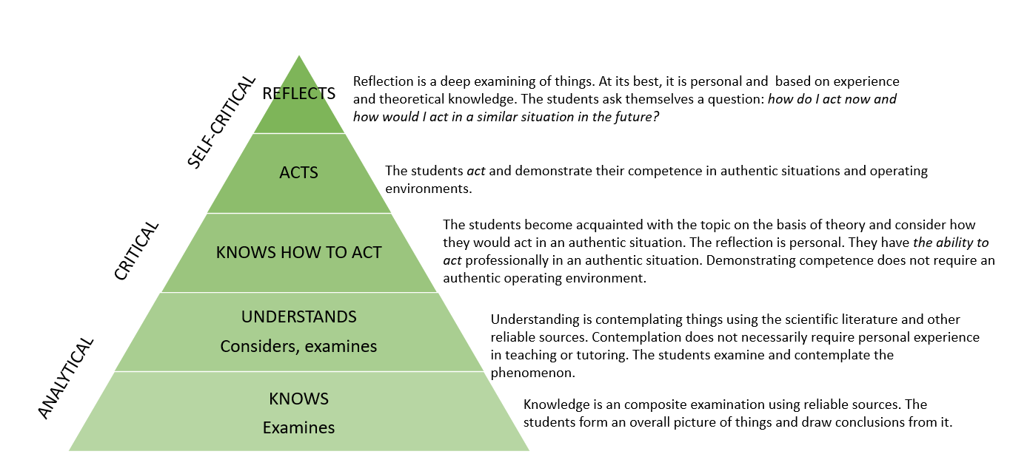

Happo, I., Karjalainen, A. & Perunka, S. 2018. Osaamisen pyramidi opiskelijan henkilökohtaisen opintopolun toteutumisen tukena ammatillisessa opettajankoulutuksessa. ePooki. Oulun ammattikorkeakoulun tutkimus- ja kehitystyön julkaisut 38. Retrieval 29.8.2024 https://urn.fi/URN:NBN:fi:amk-2018061513920
Read more information about the competence assessment.

